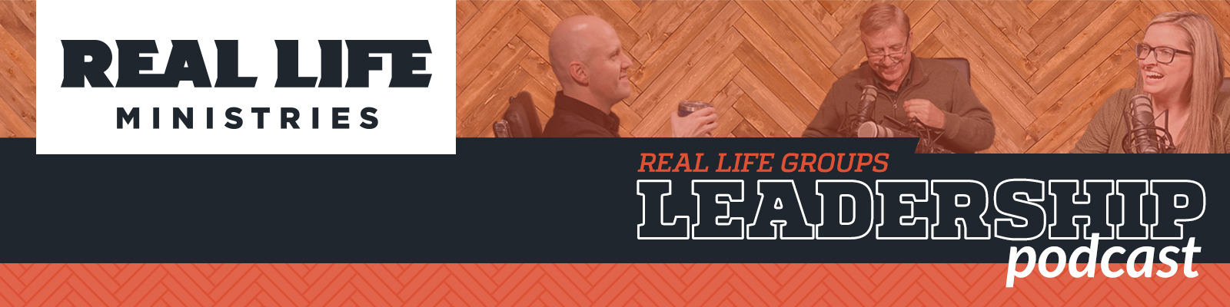

Episode 2: Strengthening the Marriages in your Small Group

Episode Notes:

In this episode of the Real Life Group Leadership Podcast, host Chris Short welcomes Bill Krause - Real Life Family Pastor and Sara Short - Groups Team Leader at the Post Falls Campus. Their discussion is centered on how you, as a Small Group Leader, can help encourage and strengthen the marriages of those in your group. Both Bill and Sara bring a wealth of experience to the topic, and they each have a unique perspective that will give you different tools to put into play right away as you shepherd your group.
Some of the things they address are:
- What kind of impact do small groups have on marriages?
- What impact does serving in ministry have on a marriage?
- How can a small group strengthen the marriages of its members?
- What part does the leader play?
- What happens if group members are not transparent about their marriage struggles? How can you as a leader dig a little deeper?
- What are you asking from me as a leader? Am I expected to be a marriage counselor?
- How should group leaders respond in a reactive situation?
- What do you do if a member expects you to take on their problems for them?

RESOURCES:
We want to encourage all of you as leaders to take advantage of our classes on marriage that are available. We want our leader’s marriages to be the healthiest - you are only going to lead as healthy as you are.
You can check out the current classes by clicking below: https://www.reallifeministries.com/classes
You can download the Marriage Scripture Prayer Cards Bill mentions here: Marriage Scriptures Prayer Cards
You can find videos and studies on marriage on Right Now Media at the link below. (Remember - if you are a member of Real Life Ministries you can utilize this platform for free.)
Right Now Media: Marriage

Click below to download your free copy of the eBook Built To Last, written by Chris and Sara Short and the Real Life Marriage Team.
Built to Last

You can download a transcript of this episode HERE

